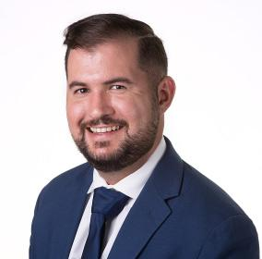
Paul Domingue Jr.

Mortgage Lending Officer

AVP | Home Bank

Paul is native of Lafayette, LA. He is a proud graduate of the University of Louisiana at Lafayette where he earned his bachelor’s degree in General Studies and a minor in History.

In 2020, Paul joined the Home Bank family as a Universal Banker. He engaged new and existing HB clients while working diligently to assist with their financial needs. In 2021, he was promoted to AVP of Mortgage and relocated to Slidell, LA. Paul currently resides in New Orleans, LA.

Paul is an avid golfer and semi-professional singer-songwriter. He works part-time at the Boys Hope Girls Hope of the Greater New Orleans Area as a mentor for at risk inner-city youth. This year, he will be studying to receive his certification as a Certified Mortgage Banker and Reverse Mortgage Specialist.

